An address is a single, structured value with multiple parts:
- Street number, Street name, Suburb, State, PIN
This is a composite attribute — it has internal structure but represents one thing.
One client → One address → Use OBJECT.

An investment is not a single item — a client can have many investments (e.g., BHP, IBM, Intel, etc.), each with:
- Company , Buy date ,Quantity ,Price
This is a one-to-many relationship:
- One client → Many investments

An OBJECT can only hold one structured value, not a list of values.
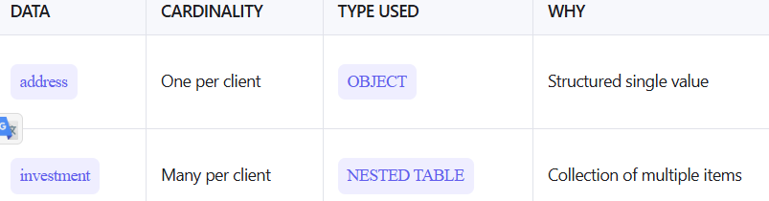

TABLE(...)
- TABLE() is a function that "flattens" a nested collection into a temporary table.
- It turns the list of investments into individual rows.
- This allows us to use it in a FROM clause like a regular table.

Why Use MEMBER OF?
'New York' MEMBER OF s.exchanges
Because exchanges is stored as a VARRAY, not a separate table. You can’t use a JOIN to find if 'New York' is inside it.

